PERSONAL INFORMATION
Name:
Last First Middle

Present Address:
Street

City State Zip

Phone No.:

Referred By: Are you 18 years or older? □ Yes □ No

EMPLOYMENT DESIRED
Date you Shift(s) Salary
Position: can start: Available: desired:
If so, may we inquire?
Are you employed now? □ Yes □ No of your present employer? □ Yes □ No

Ever applied to this company before? □ Yes □ No When?

Have you ever been employed with us before? □ Yes □ No

If so, what department? When?

EDUCATION Name and Location of School Did you Subjects Studied
Graduate? Degrees Received
□ Yes
High School □ No
□ Yes
College □ No
Trade, Business, or □ Yes
Correspondence School □ No

GENERAL
Subjects of Special Study or Research Work

Job Related Skills (Blue Print Reading Skills, CDL driver’s license, typing, etc…)

Can you travel if the job requires it? □ Yes □ No

FORMER EMPLOYERS List below your last four employers, starting with the last one first.

Date Name, Address, Telephone Salary Position Reason for
Month and Year of Employer (upon leaving) Leaving
From
To
From
To
From
To
From
To

If you are to be hired by the company, you will be required to attest to your identity and employment eligibility, and to present documents confirming your identity and employment eligibility. You cannot be hired if you cannot comply with these requirements.

AUTHORIZATION
I certify that the facts contained in this application (and accompanying resume, if any) are true to the best of my knowledge. I understand that any false statement, omission or misrepresentation on this application is sufficient cause for refusal to hire, or dismissal if I have been employed, no matter when discovered by the Company.

I understand that employment is conditioned on a background check. I authorize the Company to thoroughly investigate all statements contained in my application or resume, and I authorize my former employers and references to disclose information regarding my former employment, character and general reputation to the Company, without giving me prior notice of such disclosure. In addition, I release the Company, any former employers and all references listed above from any and all claims, demands or liabilities arising out of or related to such investigation or disclosure.

I understand and agree that nothing contained in this application, or conveyed during any interview, is intended to create an employment contract. I further understand and agree that if I am hired, my employment will be “at will” and without fixed term, and may be terminated at any time, with or without cause and without prior notice, at the option of either myself or the Company. No promises regarding employment have been made to me, and I understand that no such promise or guarantee is binding upon the Company unless made in writing.

If I am offered employment, I agree to submit to a medical examination and drug test before starting work. If employed, I also agree to submit to a medical examination or drug test at any time deemed appropriate by the Company as permitted by law. I consent to such examinations and tests, and I request that the examining doctor disclose to the Company the results of the examination, which results shall remain confidential and segregated from my personnel file. I understand that my employment or continued employment, to the extent permitted by law, is contingent upon satisfactory medical examinations and drug test, and if I am hired a condition of my employment will be that I abide by the Company’s Drug and Alcohol Policy.

I understand that filling out this form does not indicate there is a position open and does not obligate the Company to hire. If hired, I agree to abide by all Company work rules, policies and procedures. The Company retains the right to revise its policies or procedures, in whole or in part, at any time.

Date: Signature:

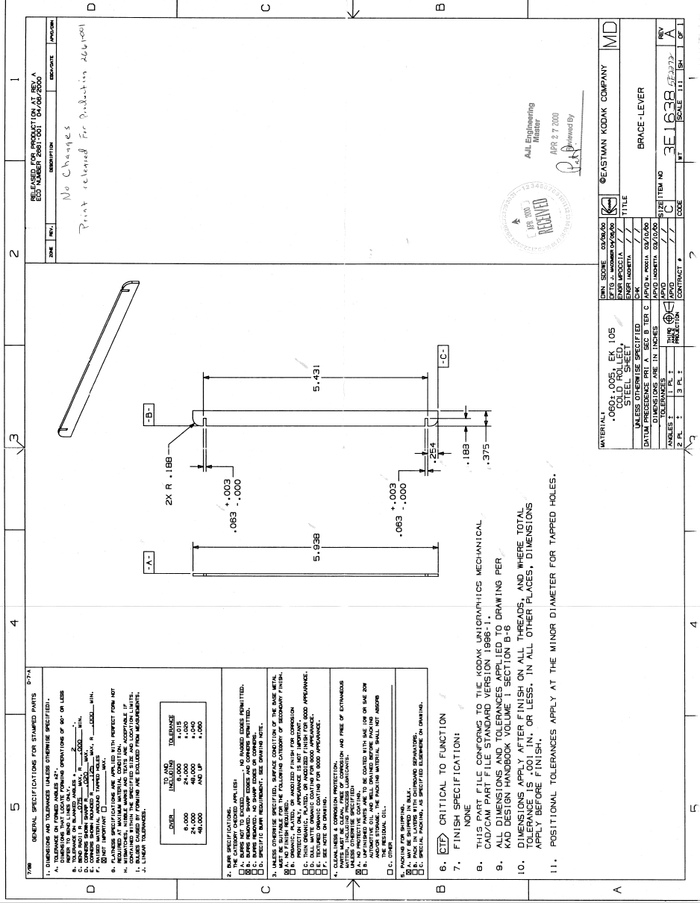
AJL MANUFACTURING BASIC BLUE PRINT PRE-TEST
Test Score will not be determining factor for scheduling interviews or Hiring Opportunities. This is used as a measurement tool only to assist Supervisors plan for candidates training needs upon hire.

Please rank your level of Blue Print Understanding on a scale of (1-5) _________
1 = Very little knowledge 3 = Average Basic Blue Print Reading 5 = Advanced Level of BP Reading

Please answer the below questions. (Refer to print on the next page)
- What is the over-all length in the side view?

- What type of material is being used?

- What is the material thickness & tolerance?

- What is the print revision?

- What do dimensions indicate?

- How is three thousandths of an inch expressed on a drawing?

- Is this part in inches or Millimeters?

- What is tolerance?

- What is the allowable maximum and minimum variation for: .063 +003/-.000?

- In the views shown, what do the letters ( A,B,C) represent?

Name ____________________________ Date _______________

